**Valley View University**

**(**[**https://vvu.edu.gh/**](https://vvu.edu.gh/)**)**



**FACULTY OF SCIENCE**

**DEPARTMENT OF INFORMATION TECHNOLOGY**

**A PROJECT SUBMITTED IN PARTIAL FULFILMENT OF THE REQUIREMENTS FOR THE BACHELOR OF SCIENCE (BSC.) IN INFORMATION TECHNOLOGY**

**TOPIC:**

**A SOCIAL PROTECTION MANAGEMENT INFORMATION SYSTEM**

**(CASE STUDY INTO SOCIAL SECURITY AND NATIONAL INSURANCE TRUST)**

**BY**

**SOLOMON YAW ADEKLO**

**(**[**https://solomonadeklo.me/**](https://solomonadeklo.me/)**)**

**(**[**https://github.com/solomonyaw**](https://github.com/solomonyaw)**)**

**ID: 213DS01000274**

**DATE:**

**15TH MAY, 2020**

Contents

ACKNOWLEDGEMENT 4

CHAPTER 1 6

CHAPTER TWO 14

C2MS INSURANCE ERP SOFTWARE 29

3.2 Background of the Existing System 33

3.3 Review of Existing System 33

3.4 Components and Features 33

3.5 Weakness of The Existing System 34

3.6 Strength of The Existing System 34

CHAPTER FOUR 36

4.2.2 Non- Functional Requirements 36

The system will remotely register all informal sector workers (Since they constitute 80% of the working population in Ghana) on to the scheme to enable them to have better retirement packages in future. Also the system will reduce the cycle whereby they need to fill out forms in order to receive their retirement benefits. Also an online payments system will facilitate cashless payments of employee financial contributions and benefits. 38

4.5.1 CONTEXT DIAGRAM OF THE PROPOSED SYSTEM 39

6.3 Testing the System 61

6.3.1 Description of the Testing Strategy 62

6.3.2 Statement of Test Case for the Proposed System 63

WEBREADER API INTEGRATION 65

CHAPTER SEVEN 67

USER MANUAL OF SYSTEM ADMINISTRATOR 67

7.1 System Home Page 67

7.1.1 System Login Interface 68

7.1.2 Admin Portal 68

7.1.3 Add Policy 69

7.1.4 Add New User 70

7.1.5 User Signup 70

This shows the signup portal where the user signs-up in order to be registered to have access to the system. 70

7.1.6 User(Employee or Customer) Portal 71

7.1.7 Customer Profile 71

This view allows the user to complete a registration form so that they can be allowed by the system to enroll in social security policies. 71

7.1.8 Enroll Policy 72

This view allows the user to enroll in social security policies. 72

7.1.9 Make Financial Contribution 73

This view allows the user to make financial contributions into social security policies. 73

7.1.10 Request Benefits 74

This view allows the user to request financial benefits from due to their financial previous obligations to social security policies. 74

7.1.11 View Report 75

This view allows the user to generate financial statement of benefits and contributions 75

CHAPTER EIGHT 75

CONCLUSION AND RECOMMENDATION 75

8.0 Conclusion 75

*References* 78

# ACKNOWLEDGEMENT

With great respect, I would like to express my most profound gratitude to God Almighty for giving me the strength and will power to complete this project, without Him I wouldn’t have had enough intellect and strength to complete this project.

I am highly indebted to my parents, especially my educational sponsor, Mr. Gibson Kodjo Kumah (C.E.O of Gibson Construction Company Limited) who supported me throughout this research work. Not to be forgotten to the entire staff of the Department of Information technology(Faculty of science) who were always there for me and gave me tremendous support throughout the project development. Thank you so much for your support.

Special thanks to Mr Prince Yaw Amoako, the lecturer and my project supervisor at the Institute of Computer Science who provided me with a vast information I needed to successfully complete this project. With no exception, a lot of thanks to my friends and individuals that I failed to mention here, who directly or indirectly contributed to this project.

**DECLARATION**

This is to declare that, the research work underlying this thesis has been carried out by the under mentioned student under the supervisor. Both student and the supervisor certify that the work documented in this thesis is the output of the research conducted by the student as part of his final year project work in partial fulfillment of the requirement of the Bachelor of Science in Information Technology degree.

STUDENT: SUPERVISOR:

SOLOMON YAW ADEKLO MR. PRINCE OWUSU AMOAKO

-------------------- -------------------

SIGNATURE SIGNATURE

DATE: DATE:

# CHAPTER 1

**GENERAL INTRODUCTION**

1. **Introduction**

Social protection is now recognized as an essential public service in developing countries, with many having established social security schemes, such as old age pensions, child benefit, disability benefits and workfare schemes. It is essential that social security schemes are well managed and to help minimize fiduciary risk. Indeed, the credibility of cash transfer schemes depends on the right money reaching the right people at the right time. Also, there is the need to integrate the most marginalized groups in society into social protection schemes since they constitute the most vulnerable beneficiaries of the program. Women and especially children count to this groups. The protection of unattended people is and will still be a challenge. Underpinning the effective implementation of schemes are Management Information Systems. Reliable information management is of crucial importance for successfully implementing social protection programs. All core processes of social protection programs, starting from registration, targeting, enrolment and payment or delivery of cash transfers, require information that needs to be captured, stored, analyzed and made accessible. Apart from the identification of applicants and beneficiaries through registration and targeting, Social Protection Management Information Systems have an important role for programs administration, rights and grievance management and monitoring and evaluation purposes. The information captured for one program may provide the basis for the selection of beneficiaries for other social programs. They also provide an important evidence base for policy making processes. Their crucial role has also been recognized as a key area of reform in social protection in developing countries. This paper proposed an integrated social protection management information system to register potential members to make contributions into social security schemes and also provide beneficiaries with online social assistance via a secure web portal.

**SUBJECT AND FIELD OF STUDY**

The subject of this study is to develop a Social Protection Management Information System whereby potential members can be registered to make contributions into social security schemes and beneficiaries can apply online for social assistance via a secure web portal.

The field of study is Information technology, specifically web development.

* 1. **STUDY OBJECTIVES**

The objectives of this study comprise both of general as well as specific objectives.

* + 1. **Global (General) objectives**

To develop a social protection management information system to register potential members online to make contributions into social security schemes and to provide social assistance to beneficiaries of the scheme via a secure web portal.

* + 1. **Specific objectives**
* Provide increased harmonization and consolidation of fragmented social protection schemes through comprehensive oversight of all social protection initiatives
* For better communication to the general population and target audiences
* To provide a single platform where common and essential information across social protection programs are stored, analyzed and reported for the benefit of the stakeholders
* To provide checks against one beneficiary receiving multiple benefits within and across program.
* Helps in the elimination of fraud by ensuring that beneficiary details are verified electronically against the database. This ensures that the programs pay only genuine beneficiaries.
* To help integrate marginalized informal workers or employees into social protection schemes and to encourage them to participate in social protection programs
  1. **BACKGROUND TO THE STUDY**

Most countries implement anti‐poverty or risk management policies and programs that are usually classified as a “social protection system.” Institutional arrangements vary widely across countries and regions but similar programs are often observed: cash or in‐kind transfers to alleviate poverty and build human capital; mandatory social insurance programs to protect workers and their families against the risk of unemployment, disease, disability, or the inability to work during old‐age; regulations that protect workers from exploitation, abuse, or accidents at work; and programs that aim to help individuals build skills, find jobs, and, in general, improve their earnings opportunities. These programs usually fall under the purview of the Ministries of Labor, Social Affairs, and/or Health and are delivered through public or private providers, including social assistance and insurance institutions, employment service offices, training centers, or private insurance companies. Although the term “system” gives the idea of interconnected programs achieving interrelated functions, the reality in most cases is that of an amalgam of programs operating with little or no coordination. For instance, most insurance programs (pensions, unemployment benefits, health insurance) operate independently despite often being part of the same institution. Even within each of type of insurance program there is considerable fragmentation. Most countries, for example, have different pension programs for civil servants, formal workers in the private sector, and agricultural workers. The health insurance program is also often divided in two: social insurance for formal sector workers and national health services for the rest. There is even less coordination between social insurance and social assistance programs, or between these two and active or passive labor market programs. Research suggests that reducing fragmentation and promoting harmonization/integration can enhance both the performance of individual programs and the overall provision of social protection. With an integrated management information system people are less likely to fall through the cracks and lack coverage for a given risk or fail to benefit from assistance if poor or vulnerable. In addition, social protection programs can complement each other within an integrated system. This paper proposed social protection management information system to register potential members to make contributions into social security schemes and also provide beneficiaries with online social assistance via a secure web portal.

* 1. **SCOPE OF STUDY**

The study is focused on a social protection information management system. The system is built using php to run on cross platform operating systems such as windows, IOS and Linux.

* 1. **SIGNIFICANCE OF THE STUDY**

Integrated data management of social protection programs can lead to more equitable distribution of resources; provide oversight of multiple schemes; establish links with other services; and increase efficiency through economies of scale. It is generally agreed that MIS enable better organization of program services, help identify differences in coverage and detect anomalous situations. The social protection MIS will improve accountability, auditing, and transparency processes. More broadly, social protection MIS will contribute to better coordination of services and linking beneficiaries with other government programs. Information in the MIS can be used by other programs, for example to target different beneficiaries. Barca and Chirchir (2014) show that integrated MIS have achieved the following impacts, within limitations:

♣ More equitable approach to the distribution of resources based on objective and comparable information.

♣ Increased responsiveness and inclusiveness of interventions.

♣ Able to serve both the chronic poor and those structurally vulnerable to poverty, as well as respond to individual shocks or large crises.

♣ Increased transparency and accountability as program information can be more easily shared and compared.

♣ Facilitated oversight of multiple schemes and reporting to policy-makers.

♣ Avoidance of duplication of effort, for example in data collection activities for program targeting.

♣ Establishment of a common payment system across all schemes, increasing efficiencies and saving costs.

♣ Avoidance of fraud or simply keep track of who is receiving what. They also note a series of impacts which might be expected from MIS, but where there is little evidence of this type of experience:

♣ Increased linkage to the complementary institutional framework and wider social and economic policies in place. ♣ Increased knowledge on issues around poverty and vulnerability.

♣ Establishment of more effective emergency responses

* 1. **METHODOLOGY**

The methodology that would be used to design and construct this Social Protection Management Information System would be incremental build software model.

**INCREMETAL BUILD SOFTWARE ENGINEERING MODEL**

The incremental build model is a method of software development where the model is designed, implemented and tested incrementally (a little more is added each time) until the product is finished. It involves both development and maintenance. The product is defined as finished when it satisfies all of its requirements. This model combines the elements of the waterfall model with the iterative philosophy of prototyping. The product is decomposed into a number of components, each of which are designed and built separately (termed as builds). Each component is delivered to the client when it is complete. This allows partial utilization of product and avoids a long development time. It also creates a large initial capital outlay with the subsequent long wait avoided. This model of development also helps ease the traumatic effect of introducing completely new system all at once.

* 1. **Expected Result of the Study and possible use**

Social protection programs which provide cash transfers and assistance directly to beneficiaries are an essential aspect of the poverty alleviation strategies of many countries. However, administering social safety nets can be complex and burdensome, generating large volumes of data. Social protection agencies must therefore leverage on social protection information management systems as tools to deliver social benefits to poor and vulnerable people with greater efficiency and maximum impact.  
This project therefore provides social protection program managers and staff with a flexible, scalable and sustainable software solution to implement and track all phases of social safety net programs on a single platform.

**PRESENTATION OF THESIS**

CHAP TER 1. General introduction (research proposal)

CHAPTER 2. Literature review

CHAPTER 3. Crystallization of the Research ProblemCHAPTER 4. Analysis of the Proposed SystemCHAPTER 5. Detailed design of the Proposed SystemCHAPTER 6. System Implementation and TestingCHAPTER 7. System DocumentationCHAPTER 8. Conclusion and Recommendations

# CHAPTER TWO

**LITERATURE REVIEW**

**2. INTRODUCTION**

This section presents a review of the existing literature on

the useful role of software systems in the management of

social insurance(protection) policies or programs and a

review of how the social security system works in a

developing country such as Ghana

**2.1.0 REVIEW OF RELATED WORK**

**2.2.0 GHANA SOCIAL SECURITY AND NATIONAL INSURANCE TRUST(CASE**

**STUDY)**

**2.2.1 INTRODUCTION**

The Social Security and National Insurance Trust (SSNIT) is a

statutory public Trust charged under the National Pensions Act

2008 Act 766 with the administration of Ghana’s Basic National

Social Security Pension Scheme and to cater for the First Tier

of the contributory three-tier scheme. The Trust is currently

the largest non-bank financial institution in the country.

The primary responsibility is to replace part of lost income of

workers in Ghana due to Old Age, Invalidity and permanent

migration of an expatriate contributor from Ghana.

The Trust is also responsible to pay survivors Lump sum to

nominated dependants of contributors in the event of death.

The Pension Scheme as administered by SSNIT has a registered

membership of over **1,307,882 million** as at **August 2017** with

over 184,761 pensioners who regularly receive their monthly

pensions from SSNIT. The annual absolute growth of pensioners is

over 12,000.

**WHAT DOES SNNIT DO?**

SSNIT has a primary duty to collect contributions to pay

pensions and other benefits as they fall due. In carrying out

this primary responsibility the Trust undertakes the following

specific duties:

· Register all employers and issue them with unique

Establishment Registration (ER) numbers.

· Register all members and issue them with individual unique

Social Security number and a Smart Card.

· Collect contributions of members and compile relevant data

related to the contributions.

· Maintain and update personal and financial records on members.

· Process benefits for members as they fall due.

· Manage and invest the social security funds.

**THE TRUST**

The Trust was established in 1972 under NRCD 127 to administer

the National Social Security Scheme. Prior to 1972, the Scheme

was administered jointly by the then Department of Pensions and

the State Insurance Corporation. The Trust administered the

Social Security Scheme as a Provident Fund Scheme until 1991

when it was converted to a Social Insurance Pension Scheme then

governed by the PNDC law 247. The scheme in Ghana was reformed

by an Act of Parliament, Act 766 of 2008 and was implemented in

January 2010 to replace all pension schemes in Ghana including

Cap 30. In 2014, the National Pensions (Amendment) Act 883 was

passed to amend portions of Act 766.

**THE CORE FUNCTIONS OF SSNIT**

* + Register employers and workers
  + Collect contributions
  + Manage records on members
  + Invest the funds of the Scheme
  + Process and pay benefits to eligible members and nominated dependants.

**ADMINISTRATION OF SNNIT**

The day-to-day administration of the Trust is headed by the

Director General assisted by three (3) Deputy Director Generals

(DDGs).

There are seven **(7) General Managers** in charge of **Investment and**

**Development (IDD), General Counsel (GC), Finance, Operations,**

**Administration and Human Resources (ADMIN/HR), Management**

**Information Systems (MIS) and Benefits**. Other responsibilities

under the Directorate include that of the **Chief Actuary, the**

**Chief Internal Auditor, the Company Secretary and the Corporate**

**Affairs Manager.**

**BENEFITS UNDER THE SSNIT SCHEME**

There are four (4) types of benefit under the SSNIT scheme that

members can enjoy depending on which contingency has occurred.

* + Superannuation Pension/ Old age Pension
  + Invalidity Pension
  + Survivor’s Lump sum.
  + Emigration benefit

**SUPERANNUATION PENSION/ OLD AGE PENSION**

To qualify for old age pension, the member must be at least 60

years and must have contributed a minimum of 180 months (15

yrs.) under act 766 and 240 months (20 yrs.) under PNDCL 247.

The member who is 55 years but below 60 years receives reduced

pension whilst the 60 year old receives full pension.

**OLD AGE/RETIREMENT PENSION**

**Qualifying Conditions**

**FULL PENSION**

To qualify for Full Pension,

* + You must be at least 60 years and
  + You must have made a minimum contribution of 180 months (15yrs.) under act 766 and 240 months (20 yrs.) under PNDCL 247.

**BASIS FOR CALCULATION OF OLD AGE PENSION**

• Age

• Average of Best 36 months / 3 years’ Salary

• Earned Pension Right – Rating for the number of months you

have contributed to the Scheme.

You can earn a “pension right” between 37.5% and 60% depending

on the number of months contributed at the time of retirement.

E.g. the minimum contributions of 180 months gives a “pension

right” of 37.5%. Every additional month over the 180 months

attracts an additional percentage of 0.09375% or 1.125% for

One (1) year respectively.

**TO CALCULATE YOUR PENSION**

Multiply your best 36 months (3 years) average salary by your

“pension right”.

**EARNED PENSION RIGHT UNDER THE NATIONAL PENSION ACT, 2008 ACT 766**

The Pension Right is 2.5% for each year of contribution for the

first 15 years and 1.125% for every additional year up to a

maximum of 60.0%.

**INVALIDITY PENSION**

To qualify for invalidity pension, the member must have

contributed for 12 months in aggregate within the last 36 months

preceding the incidence of the invalidity. He/ She must have

also been certified by a Medical Board as being incapable of any

normal gainful employment due to a permanent physical or mental

disability.

The invalidity pension is paid monthly to such a person who has

been confirmed and certified incapable of earning an income.

**INVALIDITY PENSION**

**Qualifying Conditions**

To qualify for invalidity pension:

* You must have made a minimum of 12 months/within the last

36 months with the date of termination of appointment due

to your invalidity as the reference point.

* You must have been declared permanently invalid and

incapable of any normal gainful employment:

By a qualified and recognized medical officer and

Certified by a Regional Medical Board on which a SSNIT

* Medical Officer is represented.

MEDICAL EXAMINATION

* Report to the nearest SSNIT Branch in person or through

your representative with a Medical Report from a recognized

Medical Practitioner certifying you are invalid.

* You will be required to appear before a Medical Board for

examination where your invalidity is certified by the

Medical Board.

**DEATH AND SURVIVORS LUMP SUM**

Death and Survivors Lump sum is benefit paid to nominated or

eligible beneficiaries of a deceased contributor or pensioner.

It can also be paid to persons upon an order by a court of

competent jurisdiction. This benefit is paid when a member dies

in active service or during retirement and have not attained the

age of **72 years for those under PNDCL 247 and 75 years for those**

**under the National Pensions Law, Act 766 respectively.** Deceased

member’s beneficiaries will be identified and all benefit due

paid to the beneficiaries identified.

**SURVIVOR’S LUMP SUM**

This benefit is paid to dependants of members under the

following conditions:

* When the member dies before retirement; or
* When a pensioner dies before attaining age 75.

**CALCULATION OF SURVIVORS’**

**LUMP SUM**

The benefit is computed as follows:

* Where a member dies having made at least twelve months

contributions within the last 36 months prior to the death

of the member, a lump sum payment of the earned pension of

the deceased member for a period of 15 years will be paid.

* The amount will be the present value discounted and paid to

the member’s nominated dependants.

* Where a member dies before making at least twelve months

contribution within the last 36 months, a lump sum equal to

the total contributions and interest shall be paid to the

nominated dependants.

* Where a pensioner dies before attaining age 75, a lump sum

payment based on the present value of the unexpired pension

of the member will be made to the beneficiaries.

**EMIGRATION BENEFIT**

Emigration benefit is a lump sum payment of benefit to non-

Ghanaian members of the Social Security Scheme under Act 766

whose services are ended and are leaving Ghana permanently.

Whether the member has reached the retiring age or not, whatever

benefit is due him/her will be paid as lump sum in Ghanaian

currency to the member.

To qualify for emigration benefits:

* You must be a non-Ghanaian contributor.
* You should be leaving Ghana Permanently.

**2.1.1 REVIEW OF EXISTING SYSTEMS**

**ISI ENTERPRISE**

ISI Enterprise is a fully-integrated browser-based insurance

policy administration software that helps you reengineer the way

insurance carriers do business. Most legacy systems were built

to be policy-centric, but ISI believes in putting the clients at

the heart of system, providing an end-to-end policy

administration system with a "client-centric" approach. Its

advanced architecture runs from a single database and code base

with real time processing. The solution was designed to help

insurers achieve maximum benefit from their IT systems.

**CORE MODULES OF ISI ENTERPRISE**

1. **Policy Administration System :-**

Imagine having a top-down, complete view of every client

portfolio. ISI Enterprise Policy Administration makes this a

reality by providing users a client-centric interface in order

to manage the full policy administration lifecycle.

ISI takes a broader view of what Policy Administration means to

insurers, and thus leverages the fully-integrated nature of the

ISI Enterprise solution to incorporate claims, risk control,

reinsurance, billing and financial information into Policy

Administration workflows.

*Key Features*

* Automated quote and policy life cycles
* Full transactional versioning
* Out-of-sequence transactions
* Central repository for client communication and documentation
* Flexible, configurable hierarchal policy structure
* Policy levels provide attachment points for associating rating rules, documents and underwriting data elements
* Expandable areas for gathering risk details
* Automated and manual renewal features
* Two-tiered transaction locking
* Unique user interface to facilitate multi-tasking
* Bulk import feature for large policies

*Key Benefits*

* Empowers users by providing integrated client information and at their fingertips
* Rules-based underwriting system increases efficiency
* User-friendly interface that support multi-tasking for optimal productivity

1. **Billing**

ISI Enterprise offers robust billing functionality for both

direct and broker/agency bill for all lines of business. Tight

integration with the Policy Administration module allows for a

quick view of billing status at both the client/account and

policy level, with the flexibility of modifying billing

independent of the policy. The Billing module streamlines the

billing process through tools such as automated statement

creation and delivery, Excel-based copy-and-paste account

reconciliations and batch receipt functionality.

*Key Features*

* Supports both direct bill and broker/agency bill for all lines of business
* Configurable and flexible installment/payment plans
* Configurable taxes, fees and charges including complex rules based calculations
* Integrated installment schedules with invoicing, credit card
* transactions and ACH/Automated Withdrawal
* Rules-based cancelation for non-payment functionality

*Key Benefits*

Flexible billing options catering to any distribution model

* Flexible payment plans and installment schedules
* Accurate financial data promotes effective and timely decision making
* Allows for billing changes independent of the policy
* Multi-currency facilitates operations in multiple geographical regions
* Quick view of billing status at any level

1. **Reinsurance**

Most insurers think of reinsurance processing as an

afterthought. In fact, in a recent survey, more than 80% of

property and casualty insurers handle their reinsurance

processing external to their systems using manual processes or

spreadsheets. There is a better way. ISI Enterprise allows

insurers to configure their reinsurance treaties and facultative

arrangements and automatically integrate reinsurance processing

within the policy administration and claims lifecycles. ISI

Enterprise was architected to handle even the most complex

reinsurance requirements, including retentions, layering,

complex attachment criteria and pooling.

*Key Features*

* Simple user interface to set-up and maintain treaties
* Visual presentation of reinsurance according to treaty
* layering
* Automatic assignment of reinsurance during policy and claims
* transaction
* Ability to trace reinsurance calculations
* Ability to associate reinsurance at coverage and policy levels
* A centralized module to manage all interactions with

reinsurance partners

* Bordereau report generation
* Grouping mechanism to manage reinsurance partners
* Limits for setting up reinsurance are tied to user security
* Rules-based attachment criteria

*Key Benefits*

* Transactions automatically flow through to the accounts of

reinsurers for ceded and recovery reinsurance transactions as well as receivables and payables

* Flexibility in assigning and validating conditions for treaty set-up
* Ability to trace reinsurance calculations when unexpected

results occur due to treaty set-up

1. **Accounting**

The integrated accounting module automatically captures all

insurance and general business transactions processed anywhere

within ISI Enterprise in real-time. Your financials are always

up to date and you can manage your business in real time. Define

all financial information in a customized, flexible chart of

accounts which supports multiple underwriting companies and an

inter-company configuration. Multi-currency capabilities allow

you to operate efficiently across borders. Receive financial

roll-ups for each business unit, multiple branches, countries,

geographical regions, subsidiaries and parent companies.

Maintain up-to-date sub-ledgers for all key business partners.

***Key Features***

* Configurable, flexible Chart of Accounts
* Setup automatic postings, fiscal year and periods, cheque

series and currency rates

* Perform bank reconciliations
* Fully-integrated with all other ISI Enterprise modules
* Transactions posted in real-time
* Supports multi-layered company structures
* Multi-currency capabilities

*Key Benefits*

* Real-time posting of all financial transactions from all modules of the system
* Up-to-date financial information
* Accurate financial data promotes effective and timely decision making
* Collect data in multiple ledgers, accounts payable, accounts receivable and General Ledger
* Multi-currency facilitates operations in multiple geographical regions
* Analysis of financial data with roll-ups for each company,
* multiple branches, countries, geographical regions,
* subsidiaries and parent companies.

1. **Rating & Rules Engine**

The integrated Rules Engine allows you to load and maintain

rates and business rules for all your standard and non-standard

lines of business. The intuitive interface is easy to use; rates

can be copied from Microsoft Excel, allowing business users to

effectively manage rates without programming intervention.

The Rules Engine also enables straight through processing of

policies you define as standard - based on various parameters or

user inputs – and tells the system to ensure that all unusual

risks are analyzed. To ensure consistency and improve compliance

you can systematically make complex decisions inside the Rule

Engine module.

1. **Configuration Studio**

One of the most common reasons insurers seek to replace their

policy administration systems today is the inability to roll-out

new products and make ongoing changes quickly to respond to

market demands.

Configuration Studio allows insurers to implement company specific

requirements for products, claims, billing, accounting

and workflow without having to involve programmers or modify

source code. Configuration Studio includes a robust rules engine

which facilitates the implementation of rates and business rules

throughout the core modules in ISI Enterprise.

*Key Features*

* Product configuration tools to define and manage product

definitions based on flexible package or monoline structures

* Productivity tools which streamline the configuration process including copy functions, Excel bulk import and pre-configured templates which can be leveraged to reduce time-to-market
* Full version management for all configuration elements based on dates for new business and renewal
* Screen configuration tools which enable expansion of the base data model
* Robust document configuration tools to produce and manage declaration pages, forms, letters, invoices and other

communications

* Integrated ETL tool to facilitate data exchange with 3rd party systems and services

*Key Benefits*

* Perform initial implementation and ongoing maintenance changes without modifying source code, minimizing risk and costs
* All company-specific configurations are table driven and

forward-compatible as new system versions are released

* Insurers have the option of becoming self-sufficient in

configuration without having to rely on vendor support for

ongoing changes

**MUTUAL EXPERT**

Mutual Expert’s [dot] Expert is a Web-based insurance platform

built using the latest technologies and informed by an extensive

industry experience. With [dot] Expert, you gain a powerful yet

elegant solution that integrates all facets of your insurance

operation. Mutual Expert is the insurance ecosystem created for

mutual insurance companies that elegantly integrates all aspects

of a carrier’s business.

***But what exactly is an ecosystem?***

An ecosystem is a group of interconnected elements found within

a given community. When it comes to insurance carriers, Mutual

Expert successfully unifies the different elements of a

carrier’s business. For example, within the company itself,

Mutual Expert seamlessly integrates the underwriting department

with the claims department and the accounting department.

**MODULES OF THE MUTUAL [DOT] EXPERT**

1. **POLICY**

The [dot] Expert policy module gives you complete control over

policy rating, underwriting and management. The powerful rating

engine was engineered to handle both personal and commercial

lines of business. It also gives you the flexibility you need to

maintain your own insurance products.

*Features*

* Configurable underwriting rules, rates, and formulas.
* Customizable user inbox for company messages and assignments.
* Complete inspection tracking, from initial request to compliance issues.
* Third party integrations to simplify processing.
* Automated processing based on carrier-defined rules.

1. **BILLING**

With [dot] Expert, you can reduce your carrier’s operational

cost through automation and batch processing. The billing module

streamlines the routine process, enabling your billing

department to focus on the situations that demand their

attention.

*Features*

* Company-defined payment plans and fee structures.
* Transfer money between different accounts and policy periods.
* Sweep agency and/or policyholder accounts for electronic
* payments.
* Integrate with online payment processors.
* Email billing reminders based on company rules.

1. **CLAIMS**

The [dot] Expert claims management module enables your company

to track multiple claimants per accident, each with their own

reserves and payments. By allowing both agents and policyholders

to submit first notices of loss, your company can process claims

quickly and, in turn, improve customer service.

*Features*

* Built-in diary and reminder system.
* Complete litigation tracker.
* Record salvage and subrogation.
* Track individual coverage and peril items.
* Issue Loss and LAE payments via check or EFT.

*Features*

* Custom report designer for ad-hoc reporting.
* Schedule automatic report runs and deliveries.
* Report data grouping and filtering capabilities.
* Premium and claim reinsurance reports.
* Schedule P and loss ratio analysis reports.

**PARTNER XE**

Partner XE is a cloud-based insurance agency management system

for independent agencies.

Partner XE offers accounting, claims management and policy

management. Using the system's integrated accounting

functionality, users can manage direct billing, insurance agency

billing, bank reconciliation and more. A document management

feature allows users to digitize and organize files and

information. Users can also customize naming conventions, data

entry preferences and dashboard views.

The software integrates with Microsoft Outlook to capture email

communications within the Partner XE system. It also integrates

with WebLink, UpLink and IVANS Transformation Station to pass

information directly to carriers.

**CAPABILITIES OF PARTNER XE**

1. **Integrated Accounting**

Accounting for your insurance agency should be easy and

accurate. With Partner XE’s fully integrated insurance agency

accounting your client information, policy information, and

financial information is all organized in one system.

Eliminate third party insurance software and dual entry giving

your agency real time insights into key information to better

serve your clients and more effectively grow your business.

*Features:*

* Daily processing dashboard
* Multi-level insurance producer commission splits
* Sweep transactions
* Carrier direct bill commission download
* Direct billing and reconciliation
* Insurance agency billing and reconciliation
* Bank reconciliation
* Producer reconciliation
* Vendor payables
* Branch, division, and department accounting
* Financial and production reports
* Producer reports
* Balance sheet
* Income statement
* Expense report
* Aged accounts receivable report
* Branch reports

1. **Document Management**

Paperless document management for your insurance agency is

critical, and your agency management system is the best place

for these capabilities.

Partner XE’s document management enables you and your staff to

quickly and easily attach information as well as retrieve key

documents. You can auto attach, drag and drop, and customize how

you organize document folders to make it simple to find what you

need for rapid client response time.

***Features:***

* easily attach information
* quickly find documents
* organize your way
* reduce e&o risk

1. **Email Integration**

Capturing email communications in your insurance agency

management system is essential for E&O and strong client

service.

Partner XE is designed to work seamlessly with Outlook, enabling

significant productivity improvements without any change in how

you already work. Agencies leverage the auto attach capability

to ensure all client inbound and outbound email communications

are captured in the system.

This unique innovation and one of a kind email integration saves

insurance agencies hours of work while ensuring better E&O

protection.

1. **Personalized Workflows**

Your independent insurance agency is unique. You have your own

way of doing business. You have your own processes, naming

systems, and priorities. Instead of making you adapt all

processes to your agency management system, Partner XE is

designed to adapt to your agency.

Experience freedom with custom naming conventions and multiple

options for data entry, without losing data consistency. This

allows for strong client service and standardized reporting that

helps you run your agency.

Run your business the way you want. Stay independent. Your

Partner XE agency management system will make it easy to work

the way you want to.

*Features:*

* create custom naming conventions and use your agency’s
* vocabulary.
* customize your dashboard and tracking views.
* take the paths you prefer to enter and access data.

1. **Reporting**

Produce reliable insights with the click of a button to manage

your staff, your business, and your clients. Gain valuable, real

time information on agency finances, client retention rates, new

policy business growth, and more without specialized knowledge.

For custom agency reports, SIS provides expertise and experience

service team to help you learn how to access the information or

create the reports for you.

*Features:*

* simple to use
* key insights
* accurate information
* standard and custom reports

**INSURACESS**

Insuraccess is a simple, secure solution for international insurance programs reporting. The solution is a reporting platform designed to assist insurance brokers in managing the international insurance programs of their clients. Insuraccess can be used as a private portal to give insured clients access to all their local policies in one centralized and secure location.

Insuraccess provides an intuitive user interface that makes it easy for any broker from any country to easily report their insurance programs. The solution substantially streamlines and improves the reporting of International Insurance Programs with local brokers around the world.

Insuraccess offers via the producing broker website, a private portal to multinational clients with secure, 24/7 access to all their local insurance policies and related documents.

FEATURES OF INSURACESS

##### **1.Easy to Use**

With a simple, intuitive design there is a low learning curve and no advanced technical skills needed.

##### **2.Export**

By exporting policy schedule of values to an Excel spreadsheet for further analysis, Insuraccess acts as an effective reporting & analysis tool for international clients.

##### **3.Client Portal**

Clients are immediately connected to their policy information with virtually no extra time & energy from the broker.

##### **4.Currency Converter**

Once invited, local brokers upload policies and enter the requested information using their local currency. The system converts all values to the producing broker pre-determined currency at the rate of the day.

##### **5.Custom Permissions**

Custom permissions allow the producing broker to choose what the client can or cannot see.

##### **6.Monitoring**

The system identifies which brokers who have not uploaded a requested document and allows the producing broker to send them a reminder.

## C2MS INSURANCE ERP SOFTWARE

C2MS is a proven and innovative InsurTech Cloud Insurance Software sales, claims and administration platform, designed for Commercial and Personal Lines Insurance. C2MS Cloud Insurance Software is specifically engineered to make it easier and more profitable for Insurers, MGAs and Scheme Managers to do business via the Internet and add value to traditional Insurance channels.

It is evident that significant business advantage can be gained by introducing innovative transaction and self-service automation to Commercial Lines business, this has been witnessed by the increased automation of Personal Lines over recent years, and the access to new markets that this has enabled.

By harnessing the power of Cloud technology, C2MS can scale from a small efficient setup, to a large autoscaled environment, capable of processing millions of policies, reliably, with predicable costs.

Key to the success of C2MS Cloud Insurance Software, is its ability to simplify commercial and personal lines transactions and policy administration for all users, while increasing productivity and reducing transaction costs.

This is achieved by providing enhanced levels of transaction automation and self-service facilities, which speeds up the trading process and enhances communications.

The increases in efficiency brought by C2MS can translate to an increase in capacity, by improved productivity. This provides the opportunity to grow revenue by utilizing the excess capacity to explore new channels or bring new products to market quickly.

*Features:*

#### **Website Portals**

Bring new and existing products to market through various sales channels; self-service portals, mobile apps, broker networks, aggregator websites, White Label schemes or direct to market.

#### **Broker, Agent and Consumer CRM**

Powerful CRM tools to manage Brokers, Agents and Consumers. Automate renewal invitations, provide web logins and self-service facilities. Manage relationships between accounts and assign account managers.

#### **Aggregator Support**

Seamlessly integrate with leading aggregators using C2MS APIs and surface rating engine services which provide real time quotes. Connected to MoneySuperMarket, GoCompare, Compare the Market, Confused.com and more.

#### **Powerful Product Configurator**

Using powerful GUI tools, create and configure Products from the data modelling steps through to validation, logic and mapping for web services and reporting.

#### **Policy Life-Cycle & Administration**

Handle business from the initial quote through to renewal, supporting all types of BTE and ATE Insurance. Automation tools assist with administration of renewals and lapsed policies.

#### **Securely Process Payments**

Securely process various forms of payments directly within C2MS, both within quote and buy portals and backoffice, including credit and debit cards, BACS, direct debit and premium finance.

#### **Powerful Commission Engine**

Fully configurable commission rules, based on product, insurer, channel and more. Automation of commission schedules and even support for splitting commission payments in various ways, over a set period.

#### **Underwriting Tools**

A full suite of tools to manage ratings, matrices, equations, referrals and business logic. Change rules and rates in real time and setup individualised rates per channel and/or customer.

#### **Accounting**

A fully integrated, double-entry transactional accounting system, designed to streamline and automate complex accounting workflows. Additional workflows can be added to partially or fully automate many accounting functions.

#### **Reporting**

Pre-created real-time and customisable reports for common tasks (Accounting, Marketing, Sales, Debtors, Claims, Renewals, Logs, Agents & Brokers and more...). Support for 3rd party tools such as AWS Quicksight and Microsoft PowerBI.

#### **Claims Management**

Complete claim life-cycle, from FNOL through to reimbursement. Manage claims using a variety of tools, including Mobile App technology for submission, dedicated claims portals for agents, brokers and claims administrators.

#### **Document Management**

Creation of documents and emails from predefined templates, based on workflows and events. Self-manage all document and email content.

#### **Single Tenancy Cloud Technology**

C2MS is Cloud Ready, supporting all major hosting providers, but can also be run On-Premise. C2MS operates within a virtualised environment, with dedicated resources and separate databases. No customer data is shared.

#### **API-Centric**

Providing real-time connections and feeds to and from third parties; whether aggregators, postcode lookup, car registration lookup, flood and risk databases or partners. Both SOAP and REST protocols are supported.

#### **Advanced Security for Data Protection**

Single Sign-On and 2-Factor Authentication services, provided by AuthStack and MFAStack, enables the latest in security and data protection technologies for your users and customers.

**CHAPTER THREE**

**CRYSTALLIZATION OF THE PROBLEM**

**3.1 Introduction**

This chapter will take a concrete look at how the current existing system works and also try to unlock the inefficiencies

that characterizes the system so as to ensure that an efficient system is developed.

A complete and thorough explanation of how the existing system works is represented with the aid of a context level diagram together with their advantages and disadvantages.

# 3.2 Background of the Existing System

Social protection management system are useful for the integrated data management of social protection programs which can inadvertently lead to more equitable distribution of state resources. Unfortunately, the social protection system employed in the **Ghana Social Security and National Trust**(SNNIT)is a manual system which does not:

* provide superior services to SSNIT customers or contributors
* reduce member enrolment cycle through forms,
* provide effective reporting solution,
* achieve real time processing of contribution reports
* reduce benefit processing time.

# 3.3 Review of Existing System

# 3.4 Components and Features

The existing system at **SSNIT** requires that members visit the regional offices to register for the scheme using a national identification card and other recommended cards. An Automated Fingerprint Identification System (AFIS) will be used to verify the identity of members and pensioners. This system stores the biometric information of all members and pensioners in a database for the verification of the identity of any member or pensioner at any SSNIT branch throughout Ghana. A thirteen(13) alphanumeric Social Security Numbers (SSNO’s) is generated for existing members with 8 Digit Social Security (SS) numbers. To apply for benefits, members must contact the nearest **SSNIT** Branch with their Smart Card or Biometric Card and a letter of retirement from their employer—not mandatory. The **SSNIT** Branch will then provide the member with a Pension Application Form for completion. The completed Form is then submitted to the **SSNIT** Branch.

# 3.5 Weakness of The Existing System

This manual process of registering and providing benefits to members is inefficient because the repetitive cycle whereby members need to fill out application forms for every benefit scheme that they apply for is redundant.

# 3.6 Strength of The Existing System

The use of Automated Fingerprint Identification System (AFIS) enables SSNIT to collect biometric information of all existing SSNIT members and pensioners for easy verification. This therefore prevents multiple registration of members.

**3.7 Context Diagram**

The context level diagram of the system drawn below:

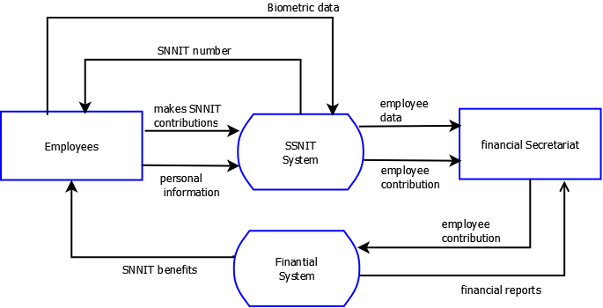

# CHAPTER FOUR

**ANALYSIS OF THE PROPOSED SYSTEM**

* 1. **Overview of the System**

In this section, a comprehensive description of the proposed system is stated, the potential requirements and procedures of the system are stated. Systems requirements present services provided by the new system. Data modeling tools like the context level diagram are used. The context level diagrams point out the main features of the system. Also is the external entities and processes of the system proposed.

* 1. **System Requirements**
     1. **Functional Requirements**

The functional requirement(s) of the proposed system describes

what the system offers to meet the user’s needs.

Their requirements include:

* + The system will register users and issue them with unique Establishment Registration (ER) numbers.
  + The system will Register users and generate a unique Social Security number for individual users
  + The system will collect contributions of users and compile relevant data related to the contributions.
  + The system will maintain and update personal and financial records on users.
  + The system will process benefits for users as they fall due.

# 4.2.2 Non- Functional Requirements

Non-functional requirements are requirements which impose constraints on the design or implementation such as performance requirements, security, and reliability: These includes:

**RELIABILITY**

Some of the reliability features are:

* The system should provide an update of all contributions made by the user/employee.
* The user should be able to rely on the system

**PERFORMANCE**

The performance requirements include:

* Database to keep records of users and their contributions
* The system should perform all its function

**USABILITY**

The usability requirement of the system includes:

* Users should use the system without difficulty.
* There should be logical interface to speed up the process.

**SECURITY**

The system has specific features that will prevent breaches and are as follows:

* Data integrity check
* The pension scheme system shall ensure that the benefit data accrued to the beneficiaries of the scheme can be accessed only by authorized users.

**ACCESIBILITY**

* The system shall be accessible to people with disabilities in accordance with the Ghanaian with disability Act, 2006 Act 715

**PORTABILITY**

* The system should efficiently be accessible on every web browser
* The system is providing accurate and reliable data.
* The system should be user-friendly.

**4.3 Major Features/Components of the Proposed System**

The main features of the system will be:

1. Employees register on the website and login to view their account page.
2. They can complete their profile information on the site.
3. Employees can enroll on Social Security scheme.

1. After enrolling employees will make contributions to the scheme. An online payment system will be integrated
2. System will also display the benefits information that the user receives after retirement
3. Employees can receive financial benefits from the social security scheme.

**4.4 Benefits of the Proposed System**

The system will remotely register all informal sector workers (Since they constitute 80% of the working population in Ghana) on to the scheme to enable them to have better retirement packages in future. Also the system will reduce the cycle whereby they need to fill out forms in order to receive their retirement benefits. Also an online payments system will facilitate cashless payments of employee financial contributions and benefits.

# 

# 4.5.1 CONTEXT DIAGRAM OF THE PROPOSED SYSTEM

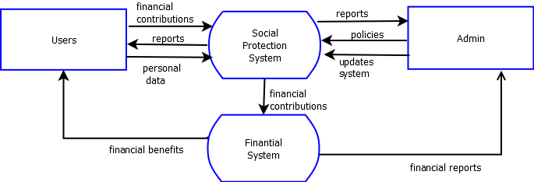

CHAPTER FIVE

DETAILED DESIGN OF THE SYSTEM

**5.1 Functional Purpose of the Proposed System**

This chapter elaborates all the significant modules of the proposed system that would be outlined, followed by the individual functional processes within the modules or components of the system.

The functional process diagram of both the Administrator and user is also stated in this section. The task that the  
administrator/user can perform under the administrative module.

5.2 Algorithm and flowchart of the proposed system.

**5.2.1 Algorithm for Administrator**

STEP 1: START

STEP 2: Administrator login

STEP 3: Login authentication

STEP 4: Add social protection policy

STEP 5: Create users

STEP 6: View users

STEP 7: View reports

STEP 8: Approve and process financial benefits to users

STEP 9: Logout

STEP 10: Return to Step 1

STEP 11: Stop

**5.2.2 Algorithm for employees**

STEP 1: START

STEP 2: User login or go to register

STEP 3: Complete registration form or user profile

STEP 4: Enroll social protection policy

STEP 5: Make contributions or payments

STEP 6: Request Benefits

STEP 7: View financial reports

STEP 8: Logout

STEP 9: Return to Step 1

STEP 10: Stop

BELOW IS THE FLOWCHART OF THE SYSTEM

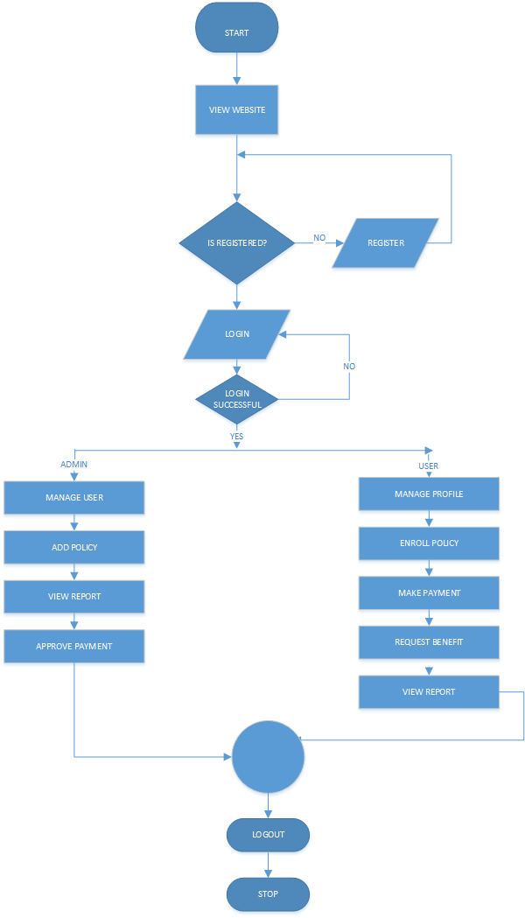

**5.3 Modelling the proposed system with an activity diagram**

ACTIVITY DIAGRAM OF ADMIN

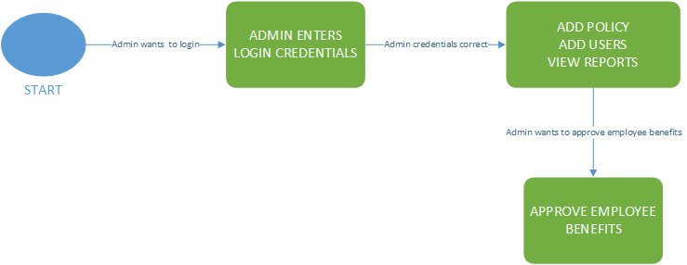

ACTIVITY DIAGRAM OF EMPLOYEE

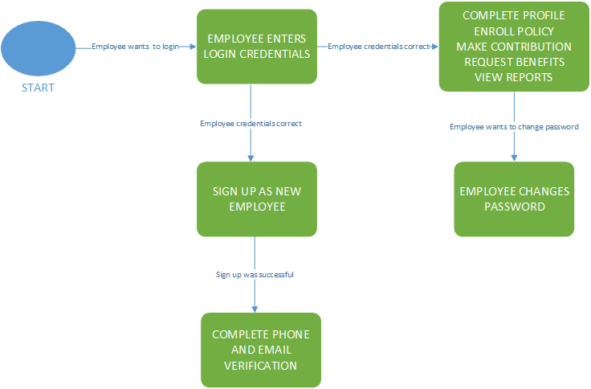

**5.3.1 Data Flow Diagram**

Below is the level 1 data flow diagram of the proposed system

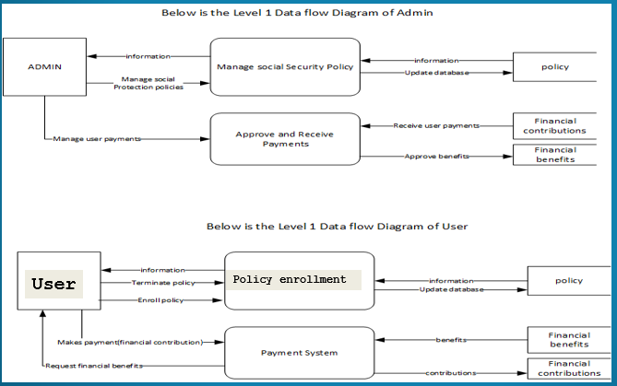

**5.3.2 Use Case Diagram**

Use case diagram is a representation of a user’s interaction with the system that shows the relationship between the user and different use cases in which the user is involved. It is used to describe the actual condition or to depict the functionality of the system.  
The figure below shows the use case diagram of the proposed system and illustrates the main actors, use cases, and their  
relationships.

Below is the use case diagram of the proposed system

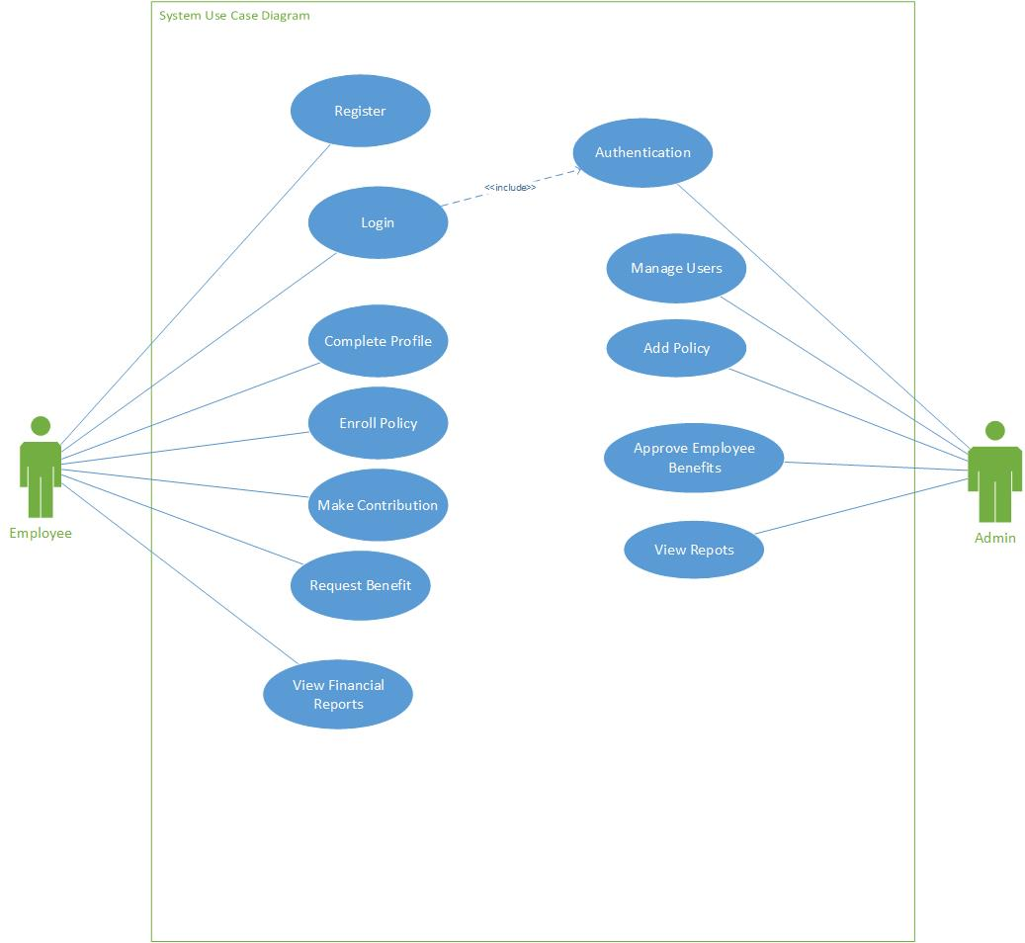

**5.3.3 Use case actors and their description**

|  |  |
| --- | --- |
| **ACTORS** | **DESCRIPTION** |
| ADMINISTRATOR | A system user charged with the responsibility of adding social protection policies and also approving and processing financial benefits to employees |
| Clients | A system user who makes financial contribution into social protection schemes and also receives financial benefits when the time is due. |
| **USE CASE** | **DESCRIPTION** |
| LOGIN | This use case allows the user to access entry into the system |
| MANAGE USERS | This use case allows the system administrator to update and delete users |
| REGISTRATION | This use case allows the system administrator to add new users to the system |
| ADD POLICY | This use case allows the system administrator to add multiple social protection schemes or policies to the system |
| MAKE CONTRIBUTIONS | This use case allows the employee make financial contributions into social protections schemes or policies |
| ENROLL POLICY | This use case allows the employee to enroll into multiple social protection schemes or policies |
| REQUEST BENEFITS | This use case allows the employee to request for funds or benefit when the right time is due |
| APPROVE BENEFITS | This use case allows the system administrator to approve financial payments to employees |
| LOGOUT | This allows users exit from the system |

**5.3.4 UML Class Diagram**

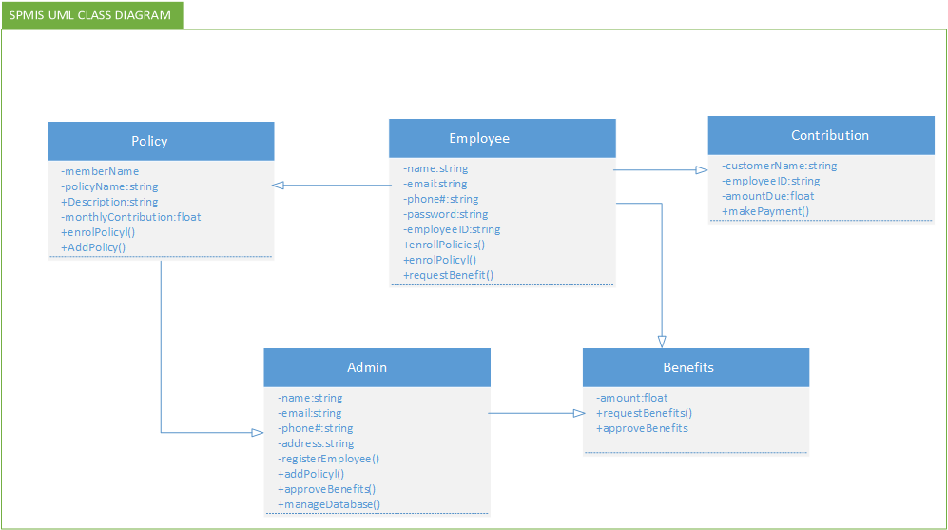

**5.3.5 Entity Relationship Diagram Of The Proposed System**

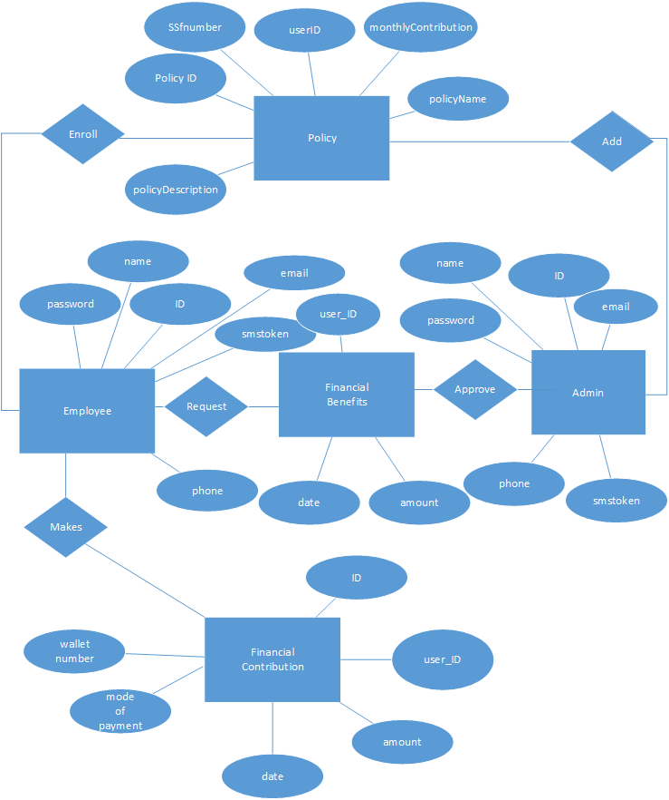

**5.3.5 Sequence Diagram Of The Proposed System**

Below is a sequence diagram of the user’s side

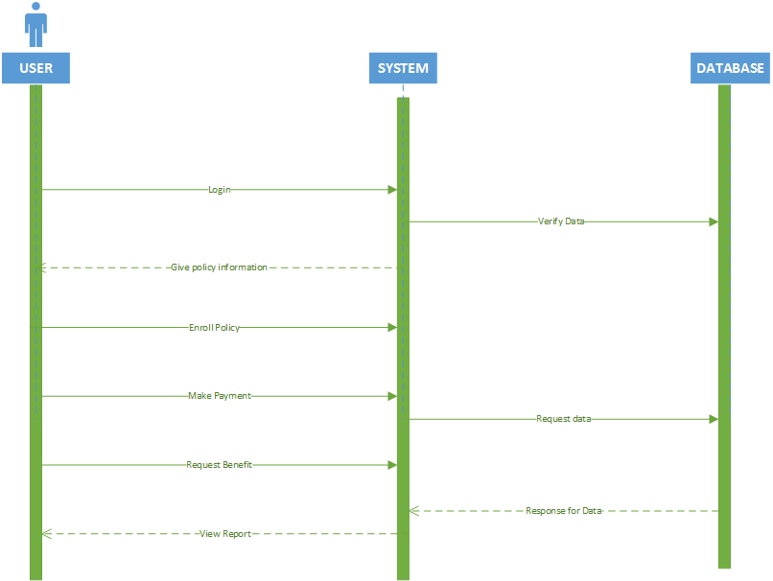

Below is a sequence diagram of the Admin’s side

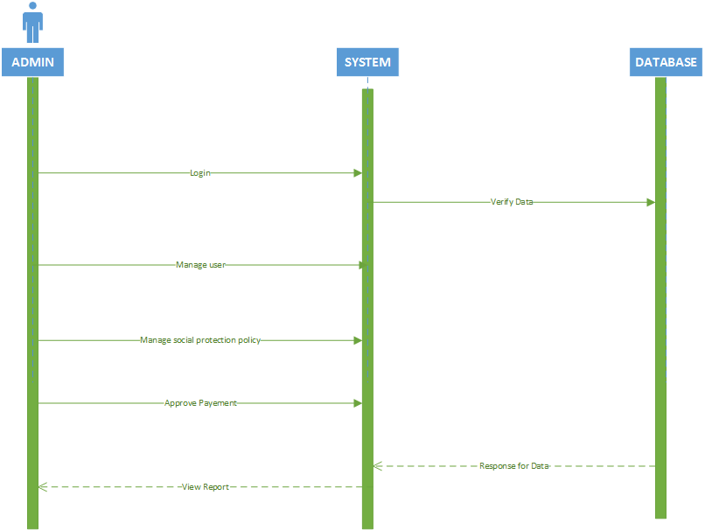

**5.3.7 Database Tables**

**User table**

|  |  |  |  |  |
| --- | --- | --- | --- | --- |
| **FIELD** | **TYPE** | **NULL** | **DEFAULT** | **COMMENTS** |
| Id | Bigint(20) | No | None | Id of user |
| Name | varchar(255) | No | None | Name of user |
| Email | varchar(255) | No | None | Email of the user |
| Password | varchar(255) | No | None | Password of user |
| Roles | varchar(255) | No | None | Determines whether the user is a customer |
| Phone | varchar(255) | No | None | Phone number of user |
| Smstoken | Varchar(255) | No | None | SMS activation token |

**Admin table**

|  |  |  |  |  |
| --- | --- | --- | --- | --- |
| **FIELD** | **TYPE** | **NULL** | **DEFAULT** | **COMMENTS** |
| Id | Bigint(20) | No | None | Id of admin |
| Name | varchar(255) | No | None | Name of admin |
| Email | varchar(255) | No | None | Email of the admin |
| Password | varchar(255) | No | None | Password of admin |
| Roles | varchar(255) | No | None | Determines whether the user is an admin |
| Phone | varchar(255) | No | None | Phone number of admin |
| Smstoken | Varchar(255) | No | None | SMS activation token |

**Customer or Employee Registration table**

|  |  |  |  |  |
| --- | --- | --- | --- | --- |
| **FIELD** | **TYPE** | **NULL** | **DEFAULT** | **COMMENTS** |
| Id | Bigint(20) | No | None | Id of customer |
| firstname | Varchar(255) | No | None | First name of customer |
| Middlename | Varchar(255) | Yes | Null | Middle name of customer |
| Lastname | Varchar(255) | No | None | Last name of customer |
| Gender | Varchar(255) | No | None | Gender of customer |
| DOB | Varchar(255) | No | None | Date of birth of customer |
| Occupation | Varchar(255) | No | None | Occupation of customer |
| SSFNumber | Varchar(255) | No | None | Social security number of customer |
| Gross salary | Varchar(255) | No | None | Gross salary of customer |
| Net Salary | Varchar(255) | No | None | Net Salary of customer |
| UserID | Varchar(255) | No | None | Id of user |
| IDnumber | Varchar(255) | No | None | ID card number of the customer |

**Enroll_policymodels table**

|  |  |  |  |  |
| --- | --- | --- | --- | --- |
| **FIELD** | **TYPE** | **NULL** | **DEFAULT** | **COMMENTS** |
| PolicyID | Bigint(20) | No | None | ID of policy |
| Ssfnumber | Varchar(255) | No | None | Social security number of employee |
| userID | Bigint(20) | No | None | User id of customer |

**Claims or Policy table**

|  |  |  |  |  |
| --- | --- | --- | --- | --- |
| **FIELD** | **TYPE** | **NULL** | **DEFAULT** | **COMMENTS** |
| Id | Bigint(20) | No | None | Id of the policy |
| Claims | Varchar(255) | No | None | Title of policy |
| Podes | Varchar(255) | No | None | Description of policy |
| mded | Double | No | None | Monthly deduction |
| bcconst | Double | No | None | Total Number of Monthly Contribution a Client Customer should make |
| age | int(11) | No | None | The age that will determine whether the user qualifies to receive his/her benefit |
| nat | Varchar(255) | No | None | Nationalities who can enroll in the policy |

**Payments table**

|  |  |  |  |  |
| --- | --- | --- | --- | --- |
| **FIELD** | **TYPE** | **NULL** | **DEFAULT** | **COMMENTS** |
| Id | Bigint(20) | No | None | Id of payment |
| UserID | Int(10) | No | None | Id of user |
| Ddate | Varchar(255) | No | None | Date of payment |
| Amt | Double | No | None | Amount contributed |
| Mode of Payment | Varchar(255) | No | None | The mode of payment |
| WalletNumber | Varchar(255) | No | None | The wallet number of employee |

**Benefits table**

|  |  |  |  |  |
| --- | --- | --- | --- | --- |
| **FIELD** | **TYPE** | **NULL** | **DEFAULT** | **COMMENTS** |
| Id | Bigint(20) | No | None | Id of benefit |
| UserID | Int(10) | No | None | Id of user |
| Ddate | Varchar(255) | No | None | Date of benefit payment |
| Amt | Double | No | None | Amount Received |
| Mode of Payment | Varchar(255) | No | None | The mode of payment |
| WalletNumber | Varchar(255) | No | None | The wallet number of employee |

**CHAPTER SIX**

SYSTEM IMPLEMENTATION AND TESTING

**6.1 Implementation**

In the implementation phase, we will look into the minimum requirements that will facilitate the implementation process.

The Social Protection Management Information System(SPMIS) is a web-based management system used to enroll both formal and informal workers to make contributions into social security(protection) schemes or policies and to receive their financial benefits when the time false due.

* 1. **Hardware and Software Requirements**

The software requires a computer system to run the application and the machine can run because all required software system are installed.

The minimum requirements for the system to run successfully are as follows:

**Recommended Operating Systems**

* **Windows:**7 or newer
* **MAC:** OSX v10.7 or higher
* **Linux:** Ubuntu

**Hardware Requirements**

* **Processor:** Minimum 1GHz;

Recommended 2GHz or more

* **Ethernet connection**: (LAN) or wireless adapter(Wi-Fi)
* **Hard Drive:** Minimum 32GB; Recommended 64 GB or more
* **Memeory(RAM):** Minimum 1GB; Recommended 4GB or above
* **Sound card w/speakers:** Required to listen to screen reader.

**Supported Browsers**

* Firefox
* Chrome

**6.2 Code Description of the system**

**6.2.1 LOGIN**

The Login portal is to ensure that only legitimate users has access to the system components. Access is granted to the user by entering their email and password. Below is the code for the login code.

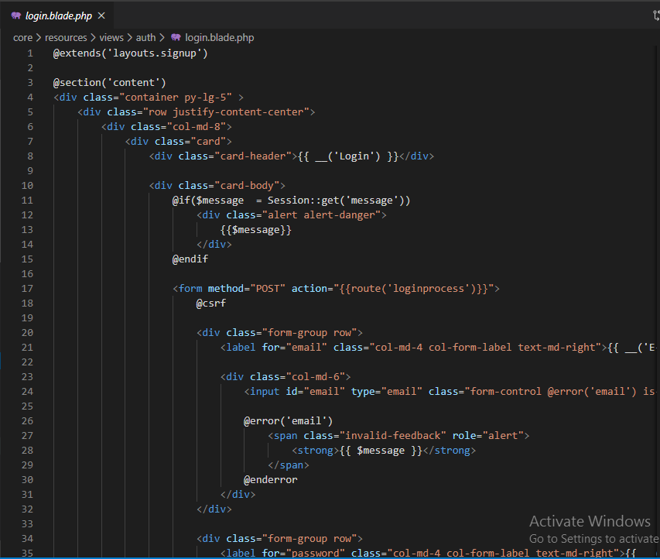

Figure 6.2.1 Login Code

**6.2.2 SIGNUP**

The signup portal is to facilitate the registration of users into the system. The user registers by entering their name, phone number, email and password. Below is the code for the signup code.

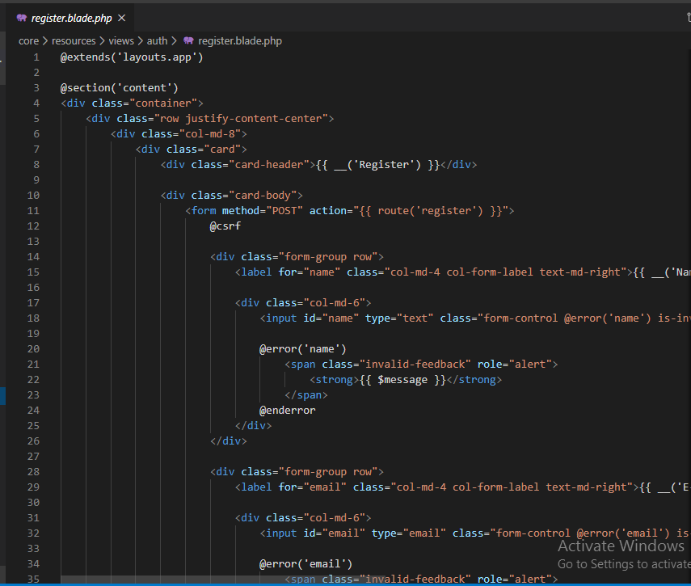

Figure 6.2.2 signup Code

**6.2.3 Admin Add Policies Page**

This is where the Admin adds a social protection policy. Below are the codes for adding policies.

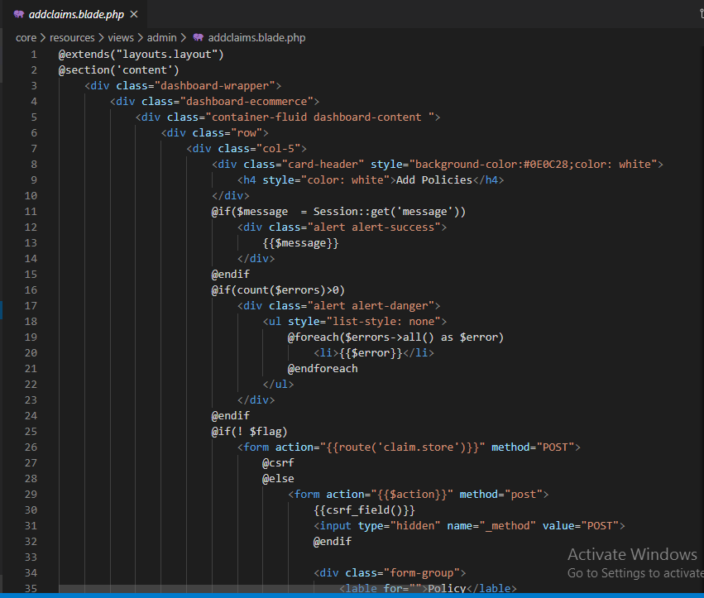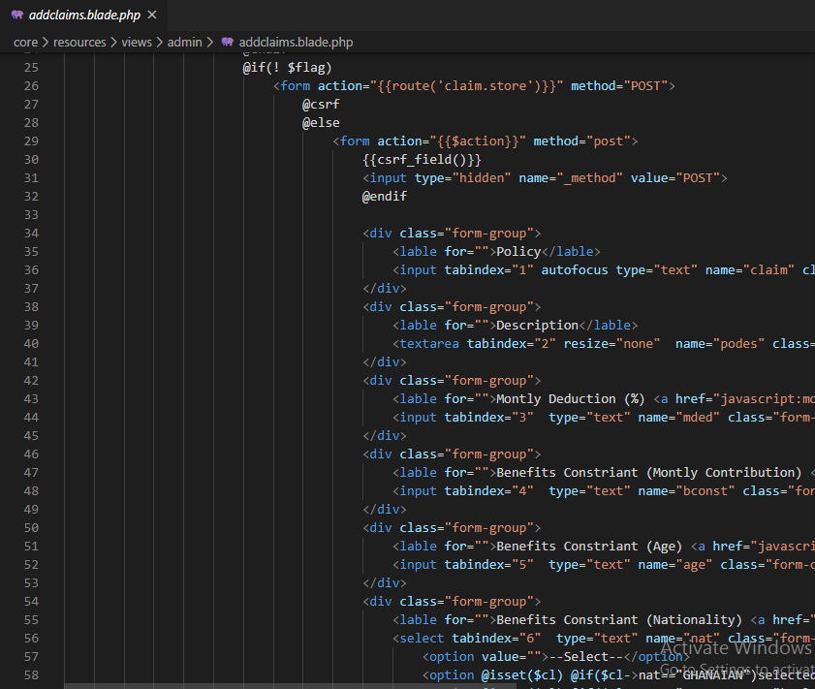

Figure 6.2.3 Add policy(claims) code

**6.2.4 Admin Create users**

This is where the Admin adds or create users on the system. Below is the code for adding users to the system.

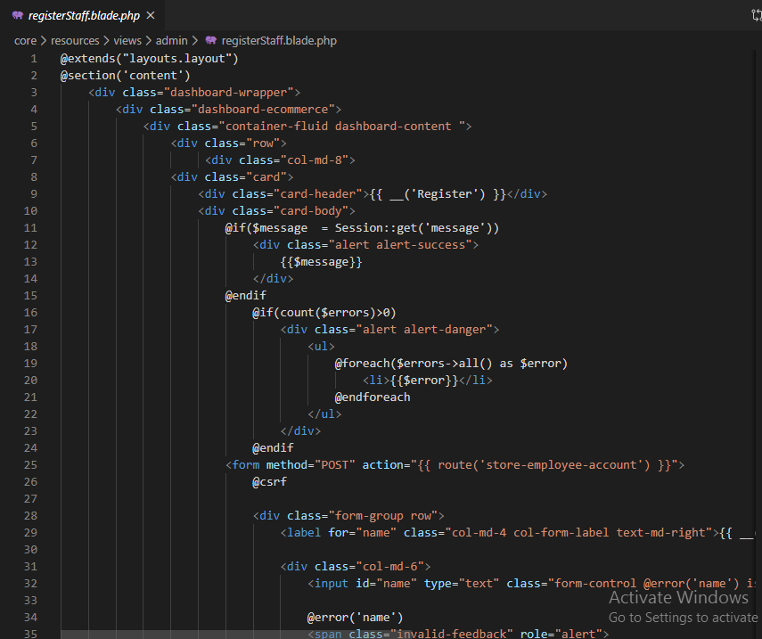

Figure 6.2.4 Add users code

**6.2.5 User fills Customer registration form (User profile)**

This is where the user fills his customer registration form in order to enroll in a social protection policy or scheme. Below is the code for filling the registration form.

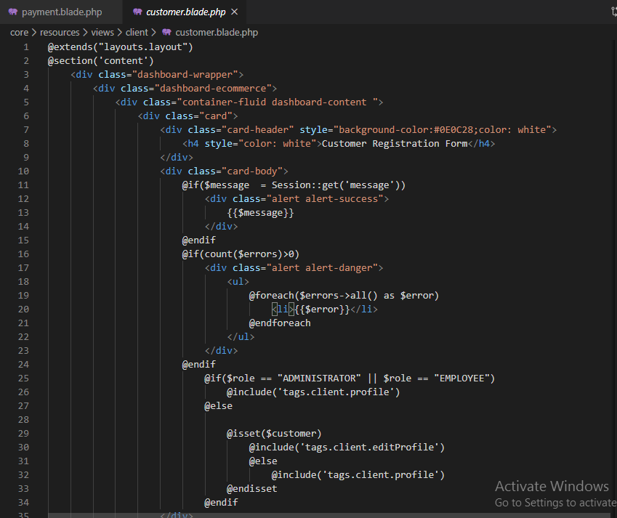

Figure 6.2.5 User profile code

**6.2.6 Enroll Policy**

This is where the user enrolls in a social protection policy or scheme. Below is the code for the enroll policy.

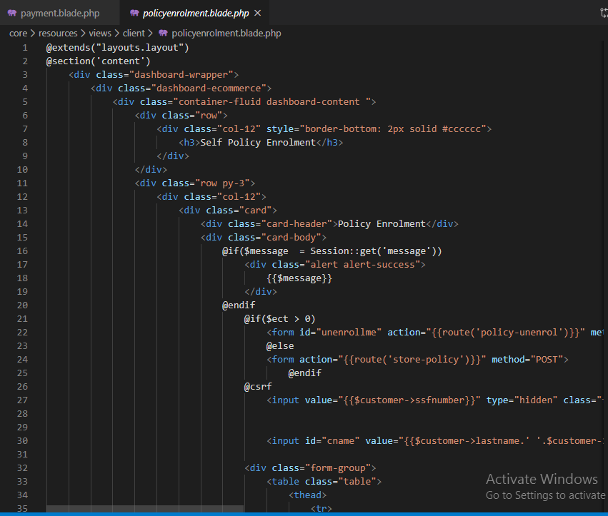

Figure 6.2.5 Enroll policy code

**6.2.6 Make Contribution**

This is where the user makes financial contributions to social protection policies or schemes. Below is the code for making financial contributions.

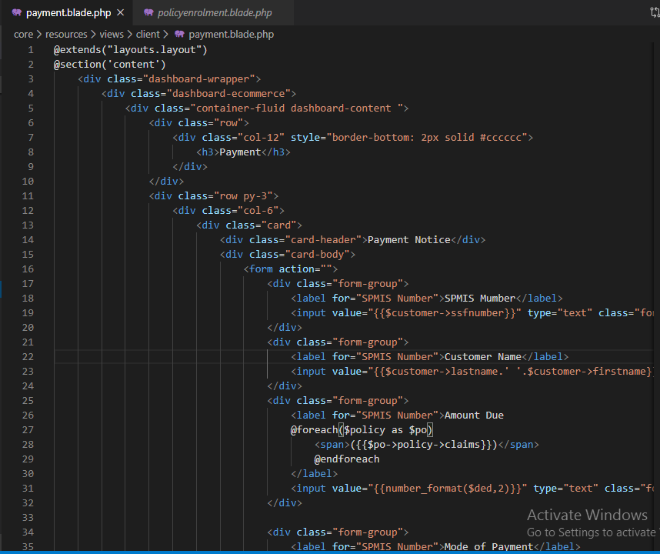

Figure 6.2.6 Financial contribution code

**6.2.7 View Financial reports**

This is where the user views and prints his or her financial reports and statements. Below is the code for viewing reports

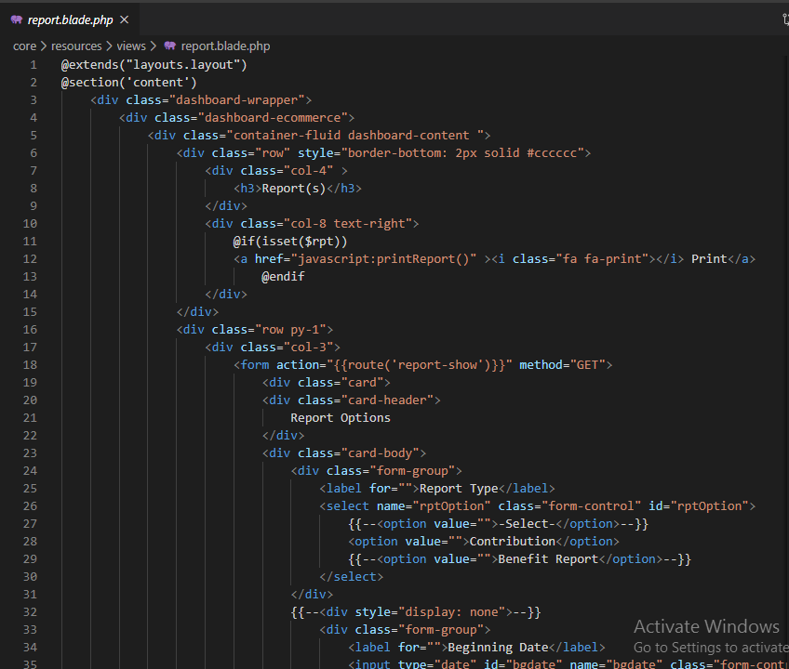

Figure 6.2.7 Financial reports code

# 6.3 Testing the System

System testing should be performed to know if the system is working correctly or not. This checks if the intended purpose of the program has been achieved.

## 6.3.1 Description of the Testing Strategy

Software testing is an activity to check whether the actual results match the expected results and to ensure that the software system is defect free. It involves the execution of a software component or system component to evaluate one or more properties of interest Software testing also helps to identify errors, gaps, or missing requirements in contrary to actual requirements. It can be done either manually or using automated tools. Some prefer saying software testing as a White Box and Black Box Testing.

Testing is important because software bugs could be expensive or even dangerous. Software bugs can potentially cause monetary and human loss, and history is full of examples.

Testing is needed at every given stage of a software’s life cycle. Testing done at the various levels during the development of software is done for different purposes/objectives.

* **Unit Testing**: Unit testing is a means of testing at the lowest level. This is usually done to test for the basic units of the software application. A unit is a basic module, i.e. the least possible set of lines of code which can be tested. This is done for continual testing and revision. Developers usually write these codes until all units’ tests are passed.
* **System Testing**: This is the stage where the whole system or application is tested as a whole. At the level, system quality is tested for and also functional, and non-functional attributes of the system are checked for (i.e. reliability, maintainability, security and requirement specifications)

Also, there are other forms of testing strategies which can be employed for this test case.

* Black-Box Testing: Is a method of testing that test the functionality and requirement of an application as opposed to its internal structures or working.
* White-Box Testing: Is an internal perspective of the system as well as the programming skills.

## 6.3.2 Statement of Test Case for the Proposed System

|  |  |  |  |
| --- | --- | --- | --- |
| TEST CASE | EXPECTED RESULTS | TESTING STRATEGY | RESULTS |
| User login | Deny access to invalid username and password and allow access to valid username and password | UNIT TESTING | Successful |
| Logout/Exit/Close |  | UNIT TESTING | Successful |
| Add Policies | Adds social protection policies and schemes | UNIT TESTING | successful |
| Enroll Policies | Enroll a user into social protection policies | UNIT TESTING | Successful |
| Performance | The number of times it takes for the system to complete processes | SYSTEM TESTING | successful |
| User Registration | Deny entry with empty name, phone number and email address | UNIT TESTING | Successful |
| Database data types | The right and appropriate data types are needed | SYSTEM TESTING | Successful |
| Database connection | All opened connection should be closed | SYSTEM TESTING | successful |
| Manage Users | The Admin manages all the Users within the system | UNIT TESTING | Successful |
| Reports | Users should have access to the report of their financial statements on contribution and benefits | UNIT TESTING | Successful |

**6.3.1 Screen Reader API Integration (Disability friendly)**

The main objective of integrating a screen reader API is to build systems that are disability friendly. The system was built in order to enable the blind to better interact with web applications. It’s a social protection management information system with a Screen Reader JavaScript API being integrated.

# WEBREADER API INTEGRATION

WebReader is a free and open source JavaScript library developed for modern web browsers. Built using emerging functionality, WebReader can be integrated into any web page. Underneath, WebReader relies on the Web Speech API to offer speech recognition and speech synthesis functionality. It integrates a subset of the features provided by classic screen readers.

A major advantage of WebReader is that it does not require any additional software to be installed on a user's machine, apart from a supported web browser.

It is built with the hope to help users with disabilities better interact with web pages. The intention is not to replace screen readers, but with basic features embedded into a web page, any user with an internet connection and a headset will be able to browse a website. It frees people form constantly looking at the screen which is useful for anyone which is on the move.

Below is the code for the screen reader

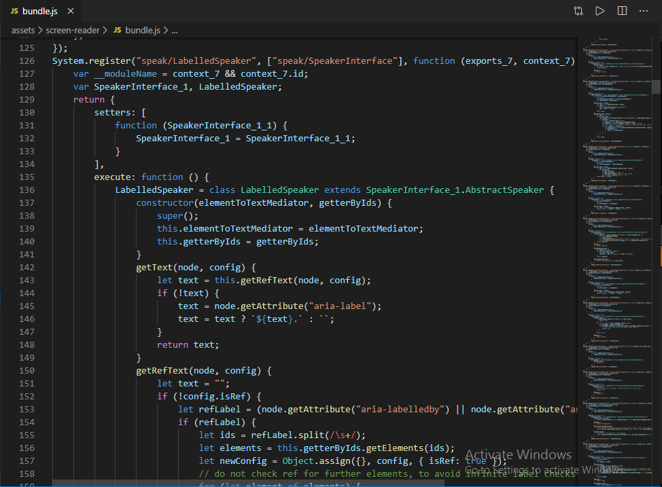

# CHAPTER SEVEN

# USER MANUAL OF SYSTEM ADMINISTRATOR AND USER

The system is a web-based social protection management information system that registers potential members online to make contributions into social security schemes(policies) and to provide social assistance to beneficiaries of the scheme via a secure web portal.

# 7.1 System Home Page

This shows the homepage of the system

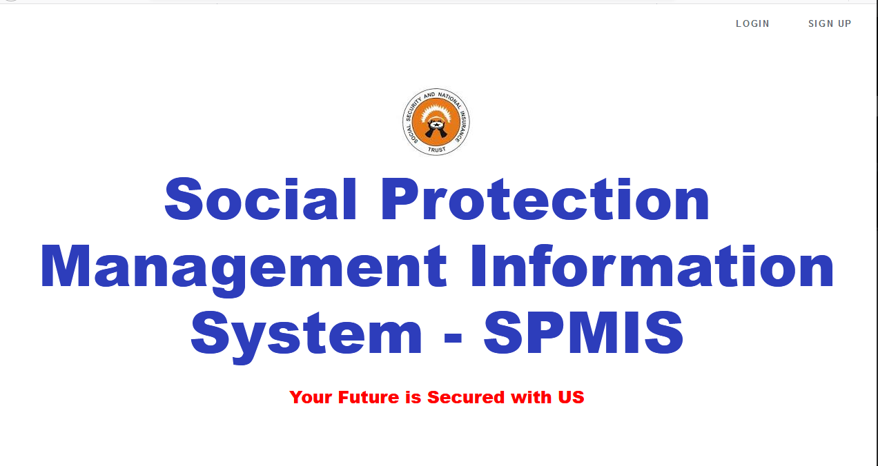

# 

# 7.1.1 System Login Interface

This shows the login portal where the user logs in as an Admin or User before they can have access to the program. This portal can be viewed by both the Admin and the User.

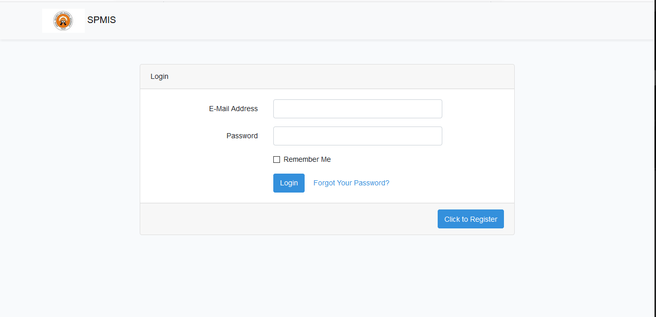

## 7.1.2 Admin Portal

This view the administrators and their privileges they can perform which includes Adding Policies, Creating users and Viewing reports.

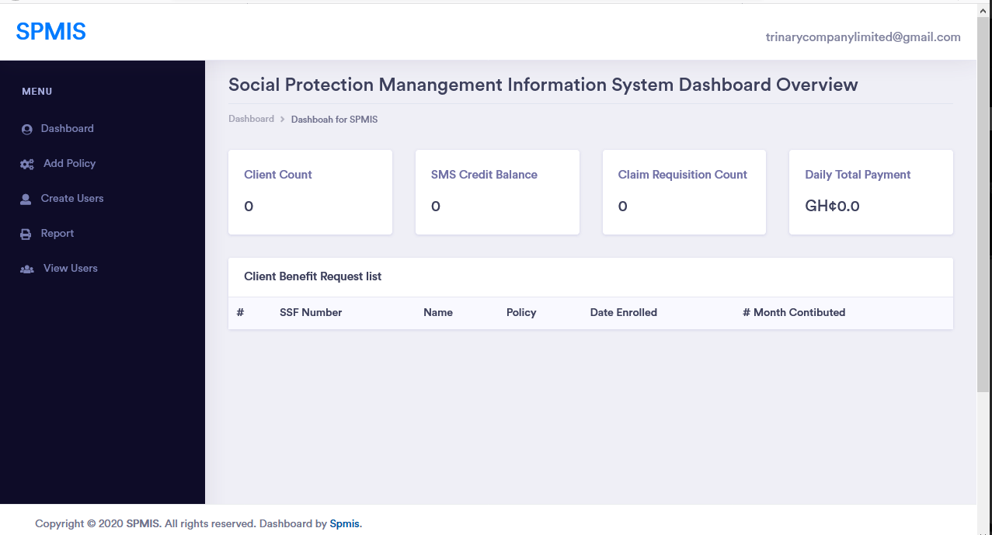

## 7.1.3 Add Policy

This allows the Admin to add social protection policies to the system

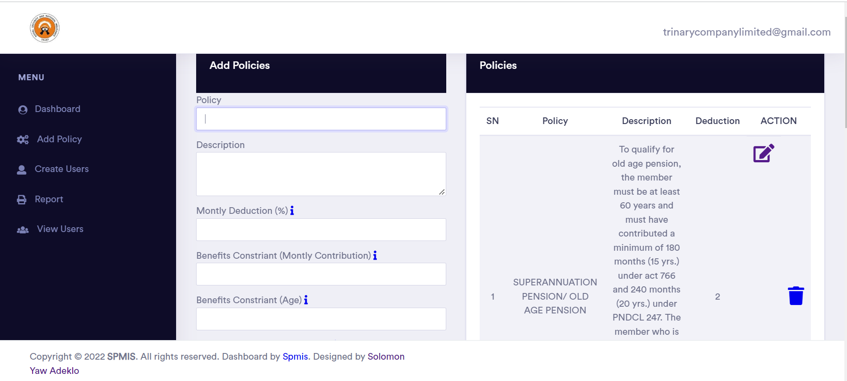

## 7.1.4 Add New User

This allows the Admin to add new Users to the system and manage their accounts

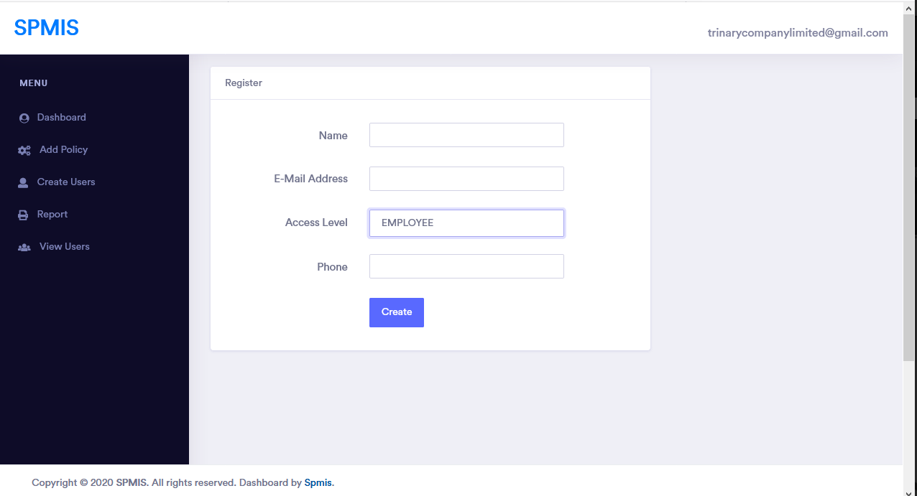

## 7.1.5 User Signup

## This shows the signup portal where the user signs-up in order to be registered to have access to the system.

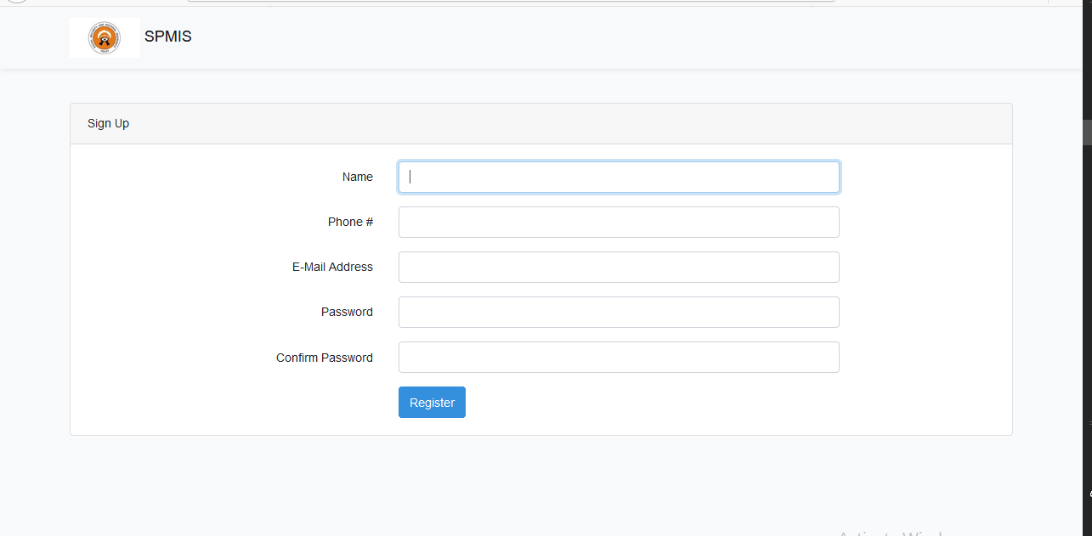

## 7.1.6 User(Employee or Customer) Portal

This views the users and their privileges they can perform which includes completing their profile, enrolling policies, making their contribution, requesting for benefits and viewing reports.

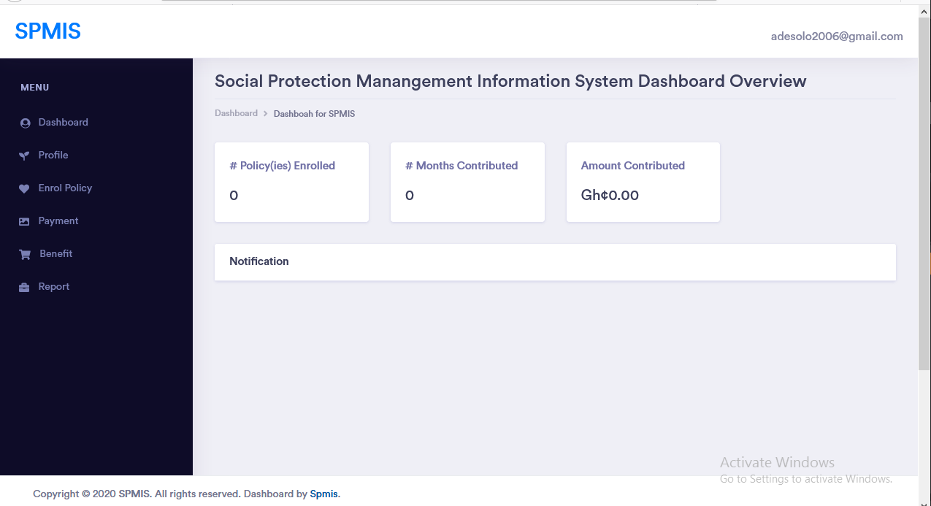

## 7.1.7 Customer Profile

### This view allows the user to complete a registration form so that they can be allowed by the system to enroll in social security policies.

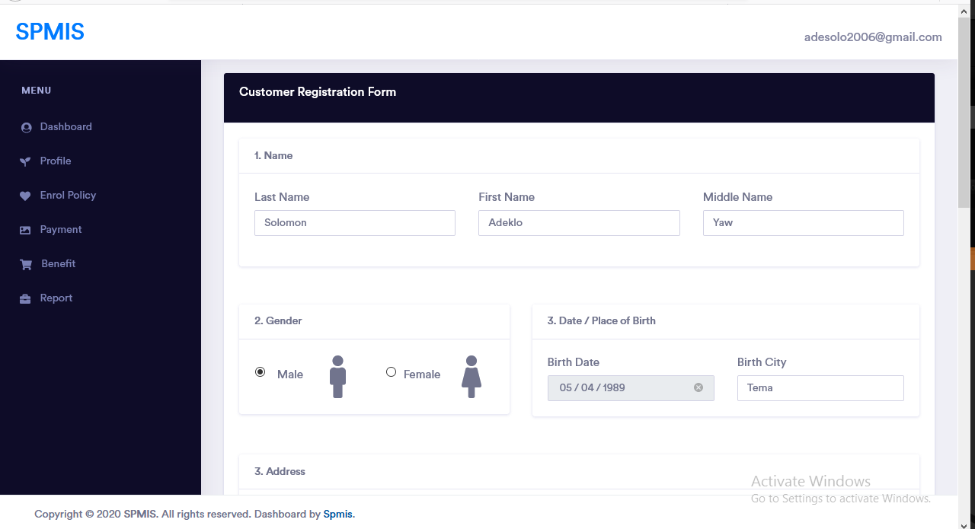

## 7.1.8 Enroll Policy

### This view allows the user to enroll in social security policies.

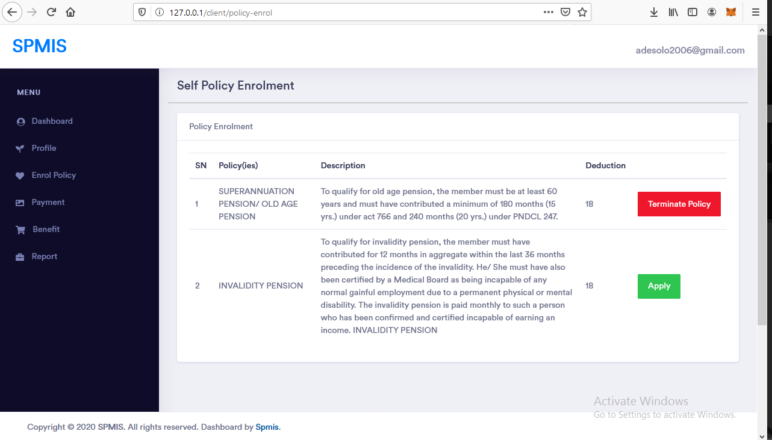

## 

## 7.1.9 Make Financial Contribution

### This view allows the user to make financial contributions into social security policies.

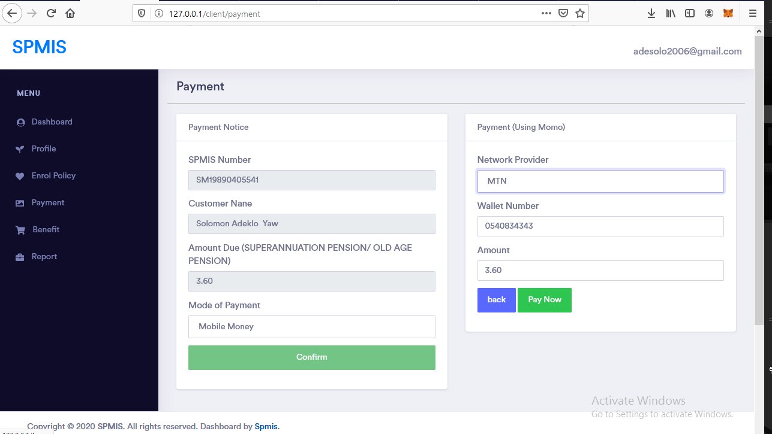

## 

## 7.1.10 Request Benefits

### This view allows the user to request financial benefits from due to their financial previous obligations to social security policies.

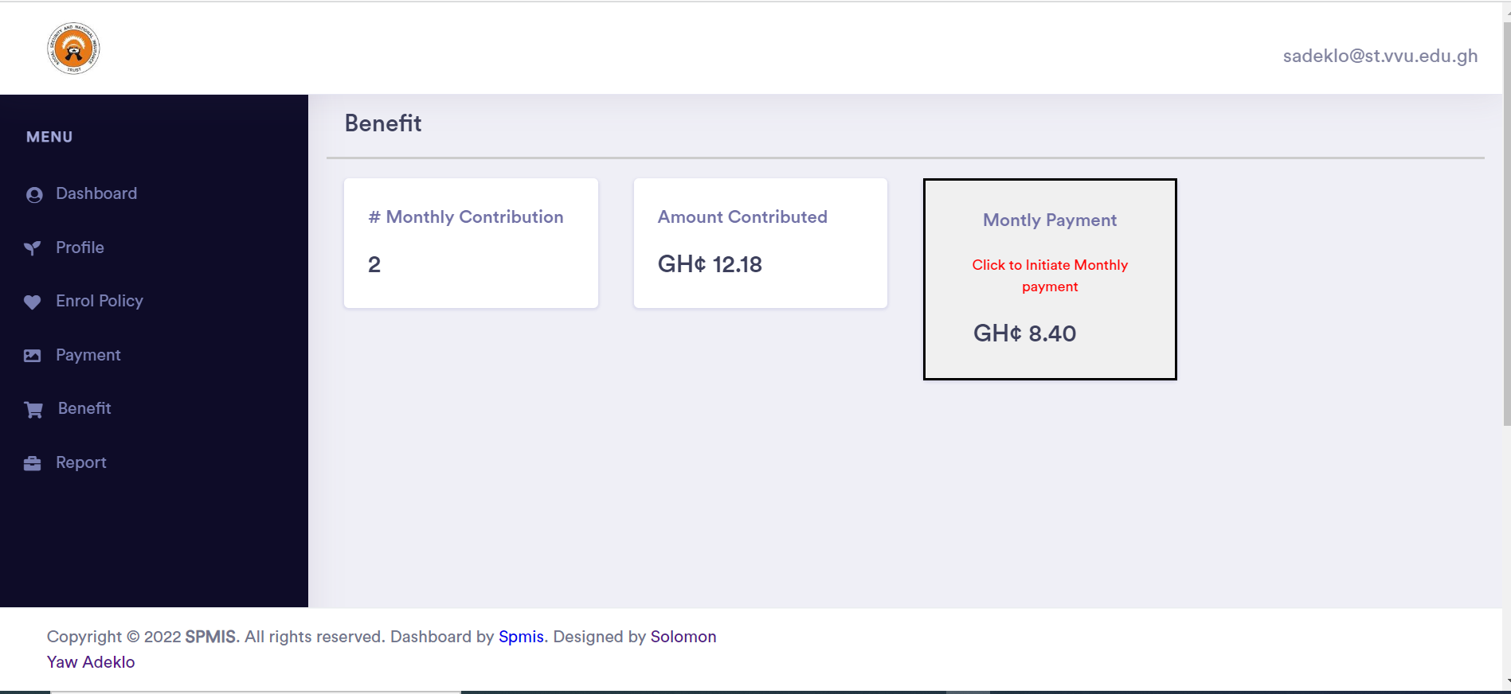

## 7.1.11 View Report

### This view allows the user to generate financial statement of benefits and contributions

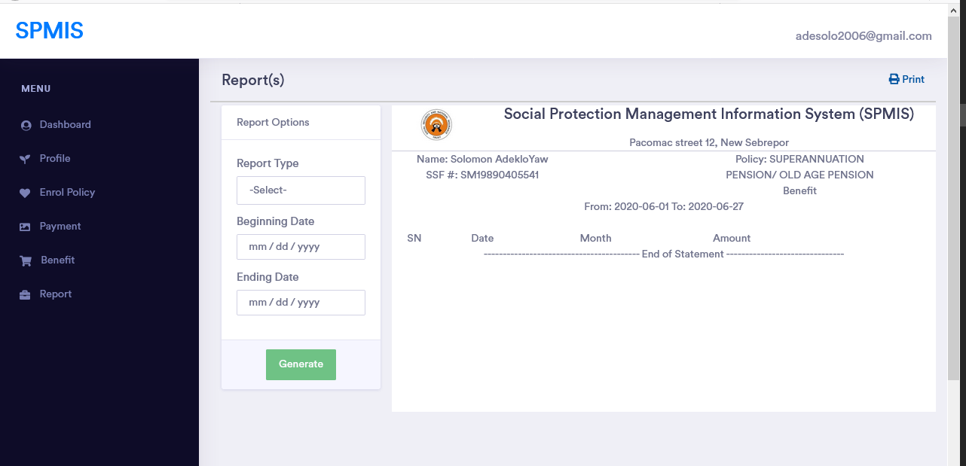

# CHAPTER EIGHT

# CONCLUSION AND RECOMMENDATION

# 8.0 Conclusion

This system, on the whole, covered what was stated in the specific objects and the expected results.

The objective of this project is to develop an efficient system which will reduce the repetitive cycle whereby beneficiaries need to fill out forms in order to receive their retirement benefits.

The project is to facilitate the enrollment of both formal and informal workers into harmonized social security schemes so they can retrieve retirement benefits when the time falls due.

The development of this involved the review of the similar existing system with the same purpose.

The first chapter of this document was on the project proposal, outlining the basis for embarking on this project which included the specific objectives.

The second chapter focused on the literature review of existing systems on the proposed project topic.

Chapter three focused on the crystallisation of the problem and vivid analysis of the existing system

Chapter four gave a partial description of the proposed system including its functional and non- functional requirement.

Chapter five gave a more detailed description of the system with diagrams depicting use case, flow charts, Entity Relationship, the UML Class and data flow diagrams.

Chapter six showed the hardware and software requirement for system implementation as well as testing strategies and statement of the test case employed to evaluate the system.

Chapter seven provides the user manual that serves as a guide for proper system use.

8.1 RecommendationsFuture development of the system should consider the following:  
• The system should integrate a biometric registration system so that potential members of SNNIT do not have to go to the SSNIT office to provide their biometric data for verification though that will require the user purchase a biometric device

• My recommendation is that in future, the SPMIS system can integrate blockchain technology(smart contracts) whereby potential members of the program can make monitory contributions using cryptocurrencies like bitcoin or ethereum since technology is veering to Web 3.0 in the 21st Century

### **References**

David A. Robalino, Laura Rawlings(2012) Building Social Protection and Labor Systems

Baldeon C and Arribas-Banos M, *Strengthening the MIS in Social Protection Programs: A Toolkit*, Washington D.C.,World Bank, 2007

Social Security and National Trust, https://www.ssnit.org.gh Retrieved from <https://www.ssnit.org.gh/about-us/> and <https://www.ssnit.org.gh/about-us/benefits/>

Joyce Abebrese, Social Protection in Ghana,2011, retreived September, 9, 2011 from <http://library.fes.de/pdf-files/bueros/ghana/10497.pdf>

Bishkek, Developing Management Information Systems for Social Protection, Deutsche Gesellschaft fu r , 6 November 2012

Sam WE, ‘Rapid Assessment of Leaps Database: Towards the Design of a Management Information System’,

unpublished work, UNICEF Ghana, 2011

<http://insurancesystems.com/products/isi-enterprise>

[accessed May 16, 2018]

[**http://insuraccess.com/index.php/features/**](http://insuraccess.com/index.php/features/)[accessed May 16, 2018]

[**https://www.buckhill.co.uk/products/c2ms-insurance-software**](https://www.buckhill.co.uk/products/c2ms-insurance-software)[accessed June 1, 2018]

[**https://www.softwareadvice.com/insurance/partner-xe-profile/**](https://www.softwareadvice.com/insurance/partner-xe-profile/)[accessed June 23, 2018]

[**https://www.mutualexpert.com/**](https://www.mutualexpert.com/)[accessed July 5, 2018]